**DAILY ONLINE ACTIVITIES SUMMARY**

|  |  |  |  |  |  |  |  |  |
| --- | --- | --- | --- | --- | --- | --- | --- | --- |
| **Date:** | **13-07-2020** | | | | | **Name:** | **Anix Jugal D’Cunha** | |
| **Sem & Sec** | **8 sem , A sec** | | | | | **USN:** | **4AL16CS013** | |
| **Online Test Summary** | | | | | | | | |
| **Subject** | | **Not Conducted** | | | | | | |
| **Max. Marks** | | **--** | | **Score** | | | **--** | |
| **Certification Course Summary** | | | | | | | | |
| **Course** | **Complete PHP OOP Concepts for Absolute Beginners + Projects** | | | | | | | |
| **Certificate Provider** | | | **Udemy** | | **Duration** | | | 10.5 hours |
| **Coding Challenges** | | | | | | | | |
| **Problem Statement:** Linear Search In Java Program. | | | | | | | | |
| **Status: Competed** | | | | | | | | |
| **Uploaded the report in Github** | | | | | **yes** | | | |
| **If yes Repository name** | | | | | **alvas-education-foundation/dcunhaanixjugal** | | | |
| **Uploaded the report in slack** | | | | | **yes** | | | |

Online Test Details: (Attach the snapshot and briefly write the report for the same)

**Not Conducted**

Certification Course Details: (Attach the snapshot and briefly write the report for the same)

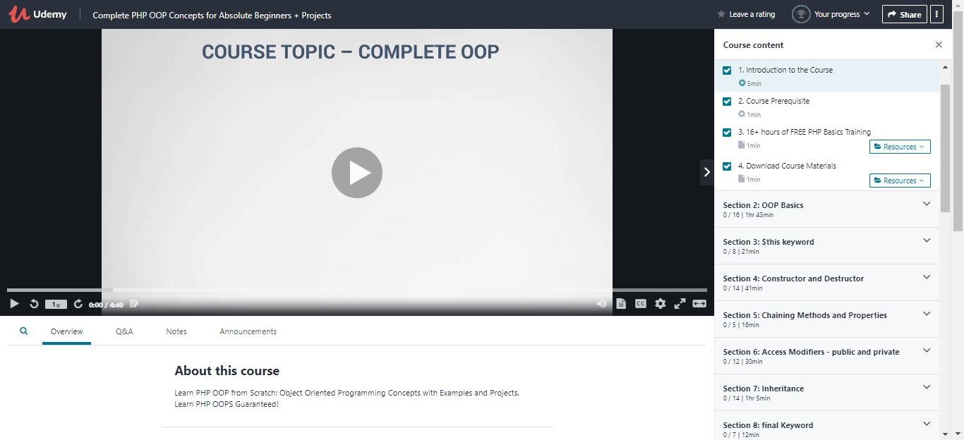

Coding Challenges Details: (Attach the snapshot and briefly write the report for the same)

## Program-> Linear Search In Java Program.

|  |
| --- |
|  |

**class Example1**

**{**

**public static void main(String args[])**

**{**

**int i,key=9;**

**int a[]={1,4,7,9,10};**

**for (i= 0; i < a.length; i++)**

**{**

**if (a[i] == key)**

**{**

**System.out.println(key+" is present at location "+(i+1));**

**break;**

**}**

**}**

**if (i == a.length)**

**System.out.println(key + " doesn't exist in array.");**

**}**

**}**

**Output:**

**9 is present at location 4**